1. Printing the numbers from 1 to 10:

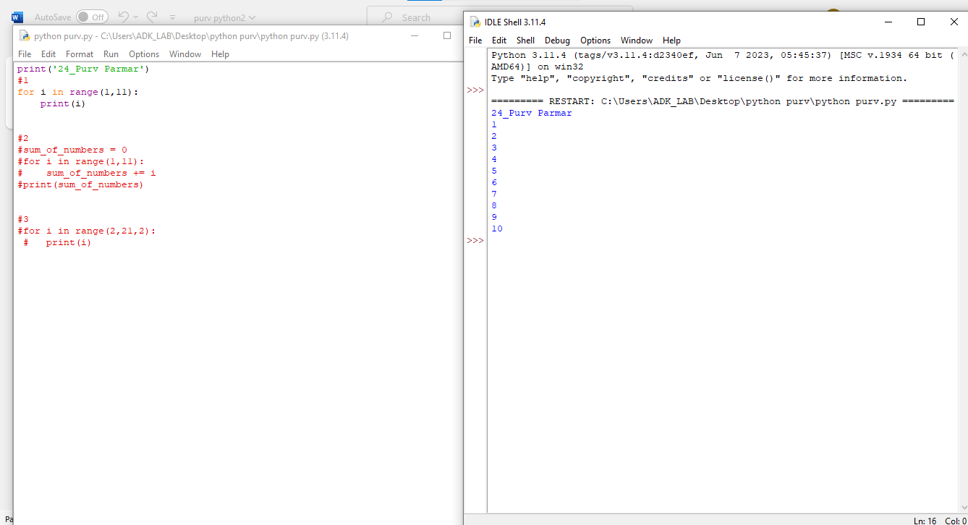

2. Sum of the first 10 natural numbers:

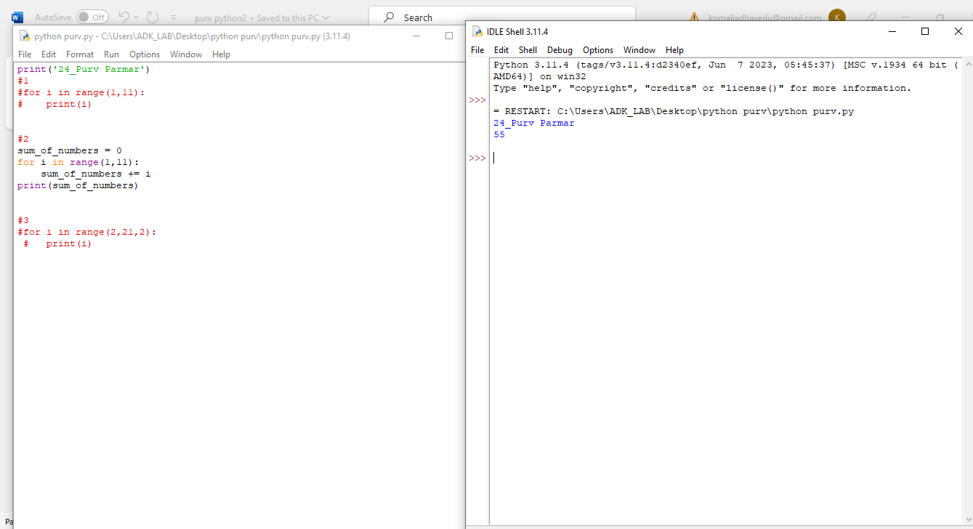

3. Printing the even numbers from 1 to 20:

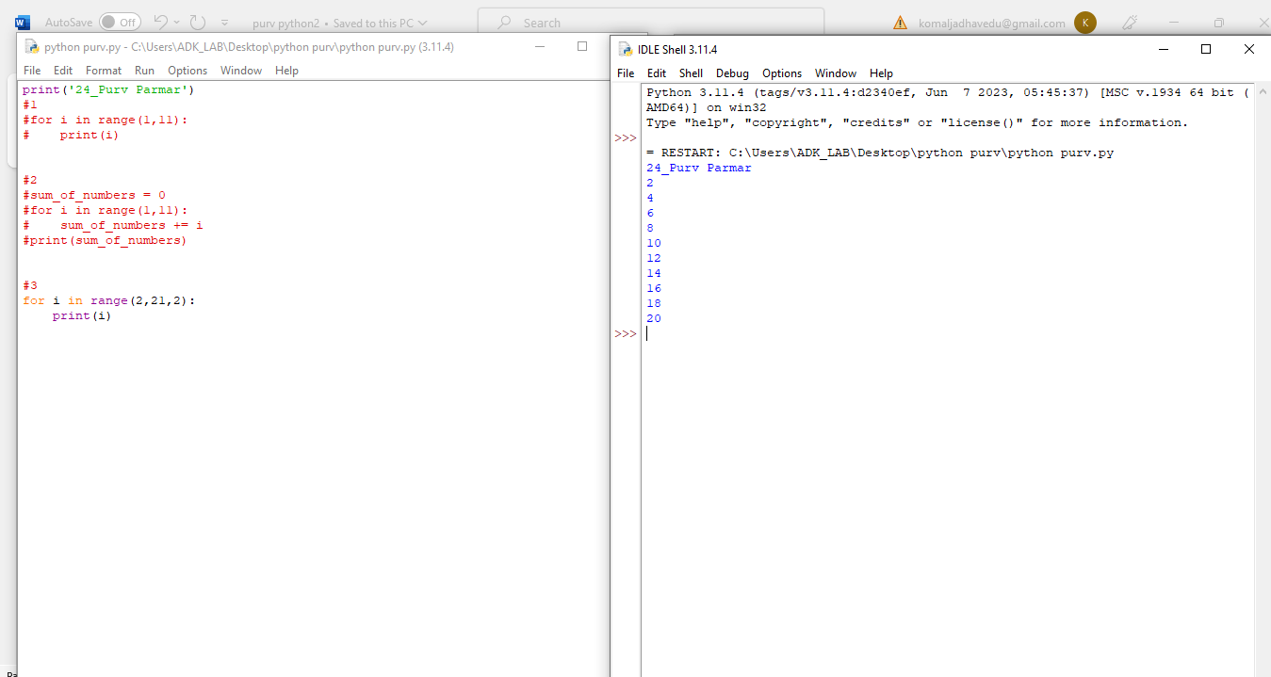

4. Printing the factorial of 5:

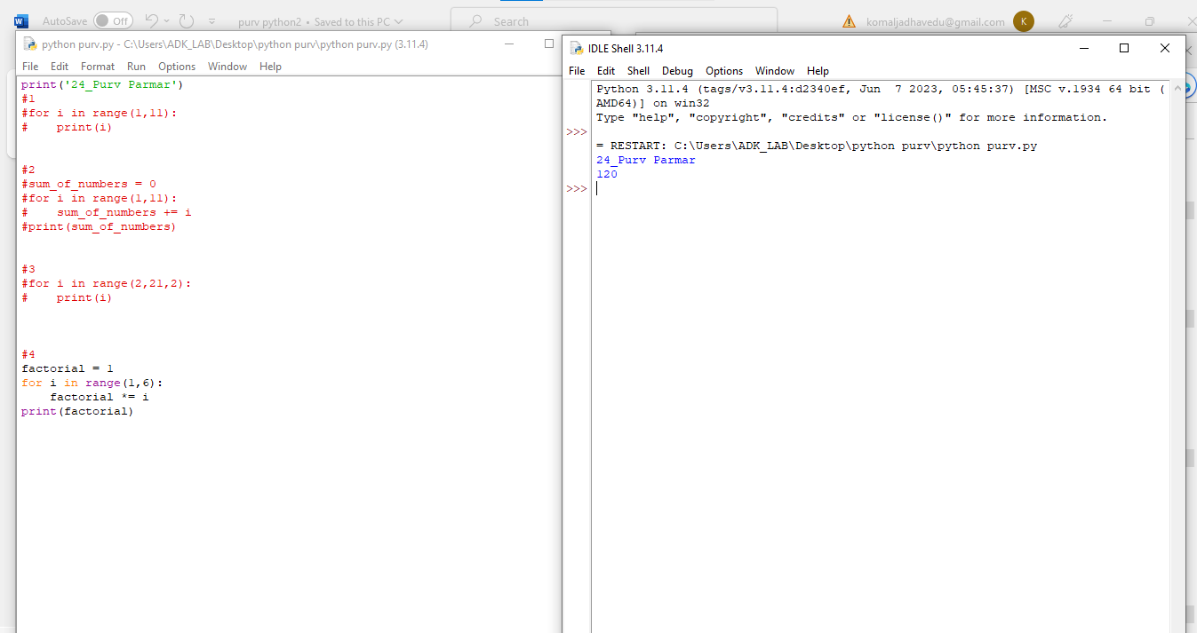

5. Printing the Fibonacci sequence up to the 10th term:

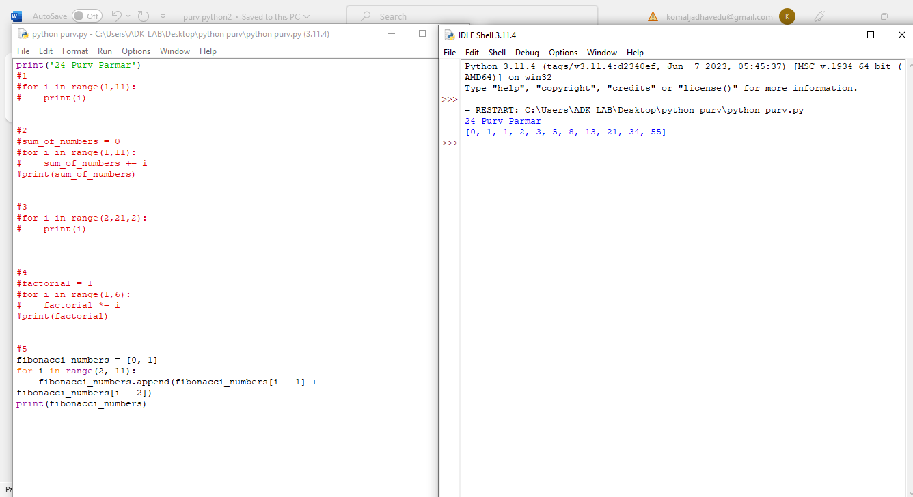

6. Printing the prime numbers from 2 to 100:

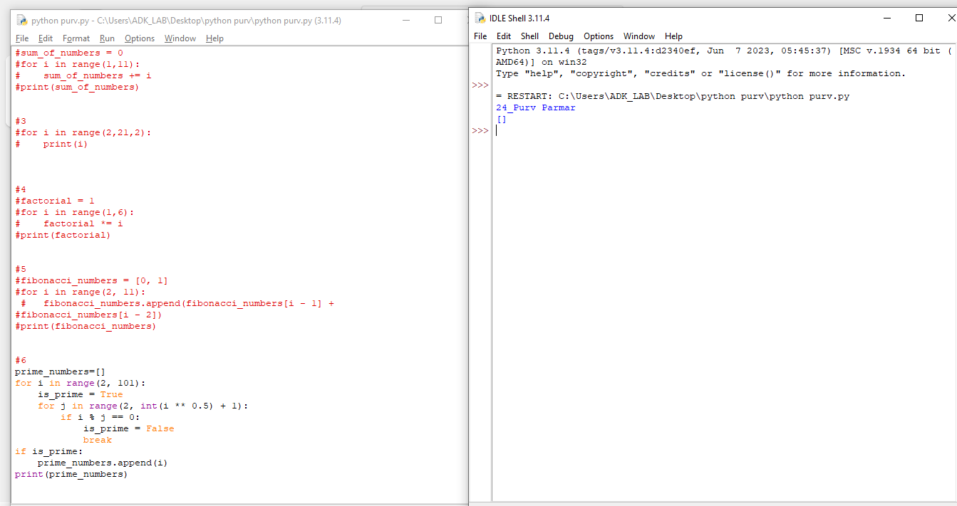

7. Printing the ASCII characters from 32 to 126:

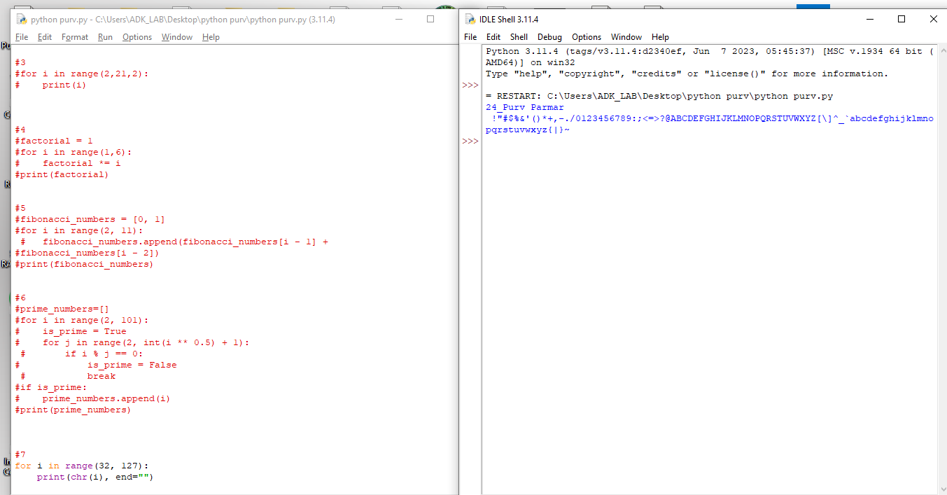

8. Printing the reverse of a string:

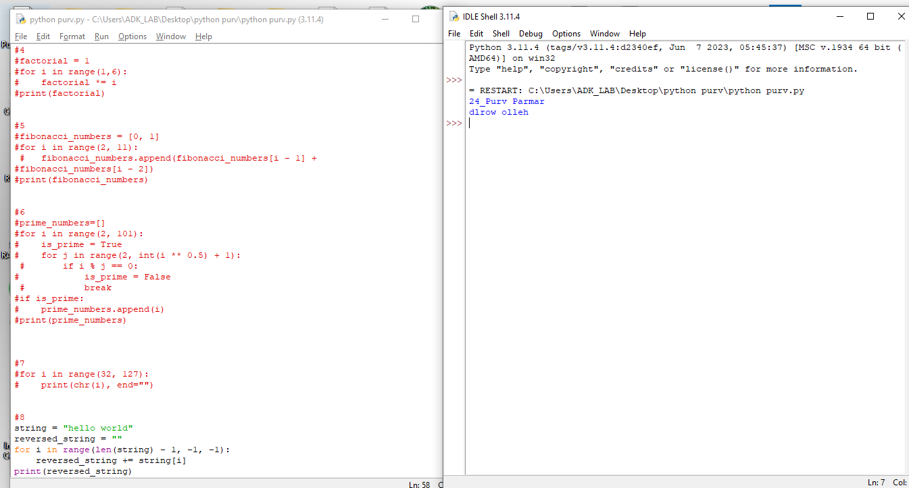

9. Checking if a number is a palindrome:

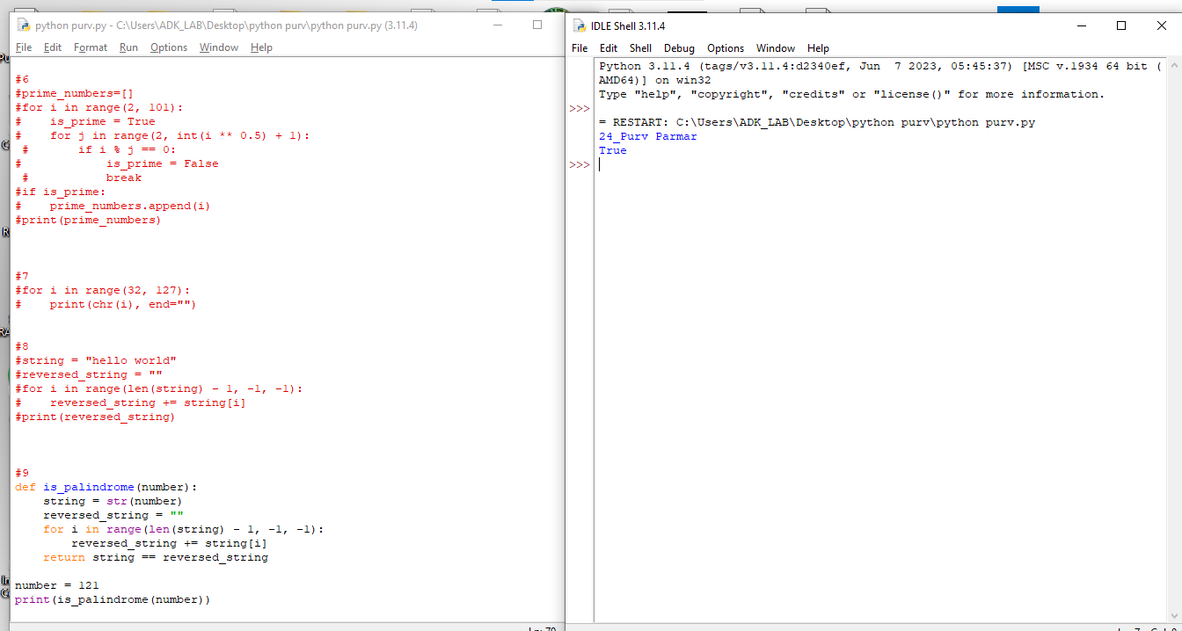

10.Printing all the possible combinations of two letters:

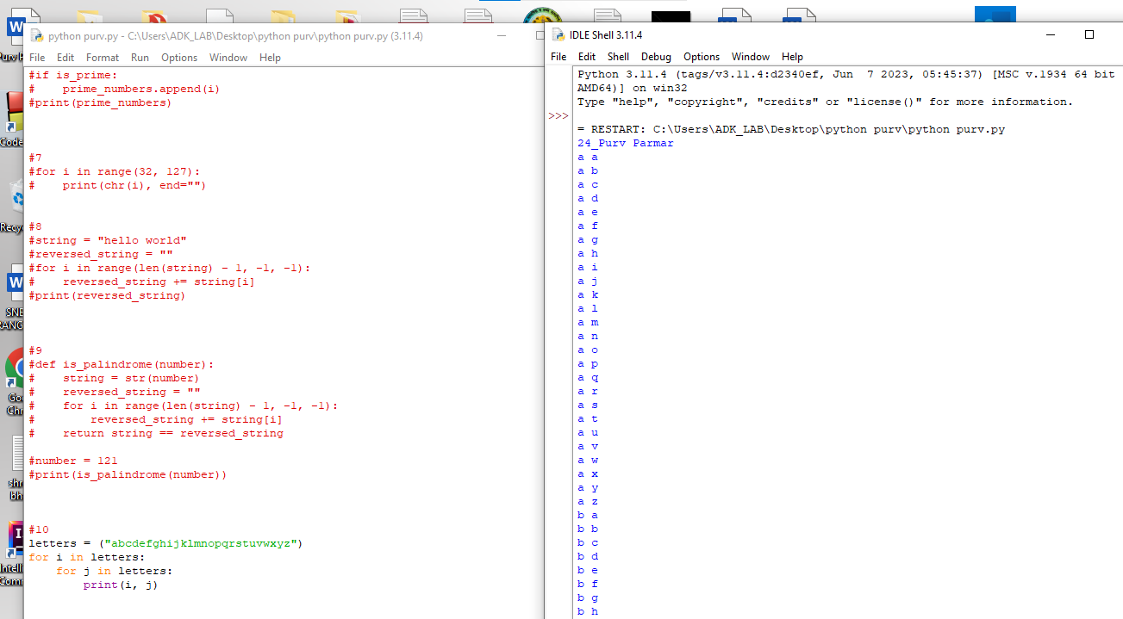

11. Printing the first 10 even Fibonacci numbers:

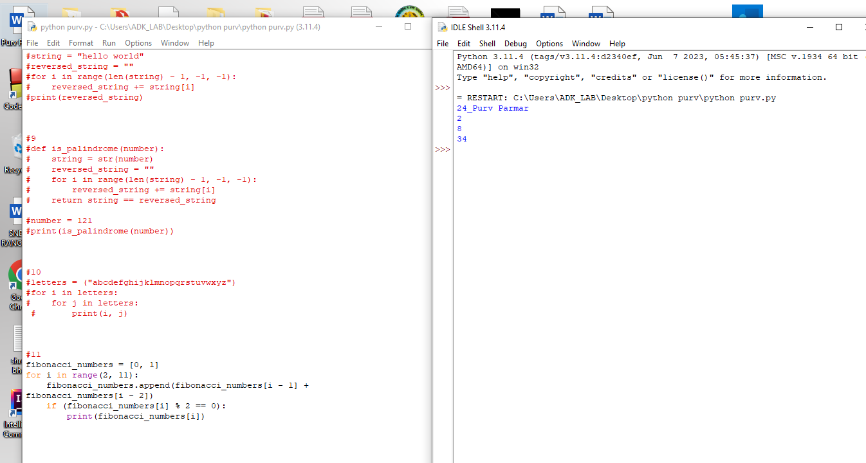

12.Finding the first 10 prime numbers greater than 100:

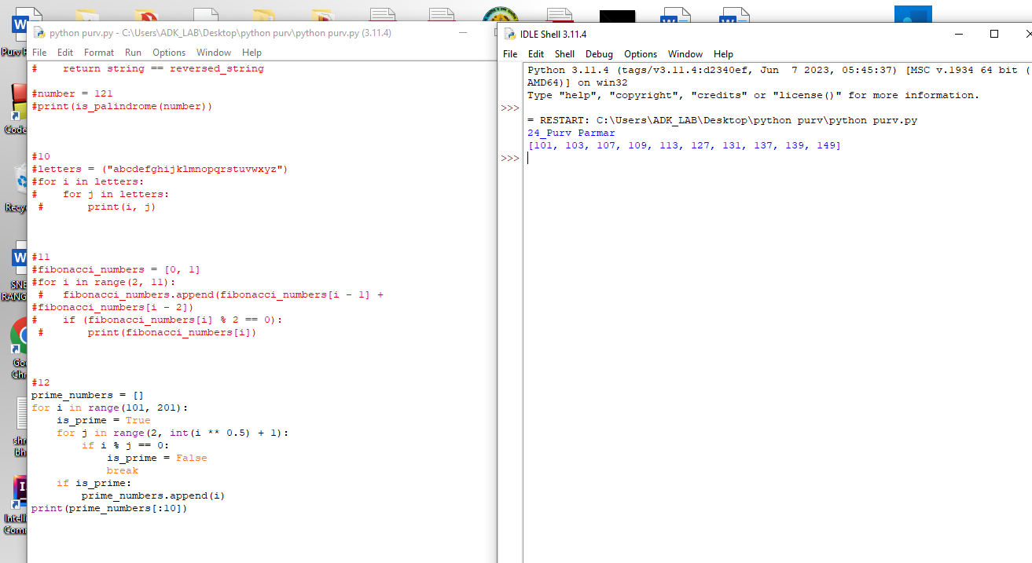

13.Printing the Fibonacci sequence in a spiral:

